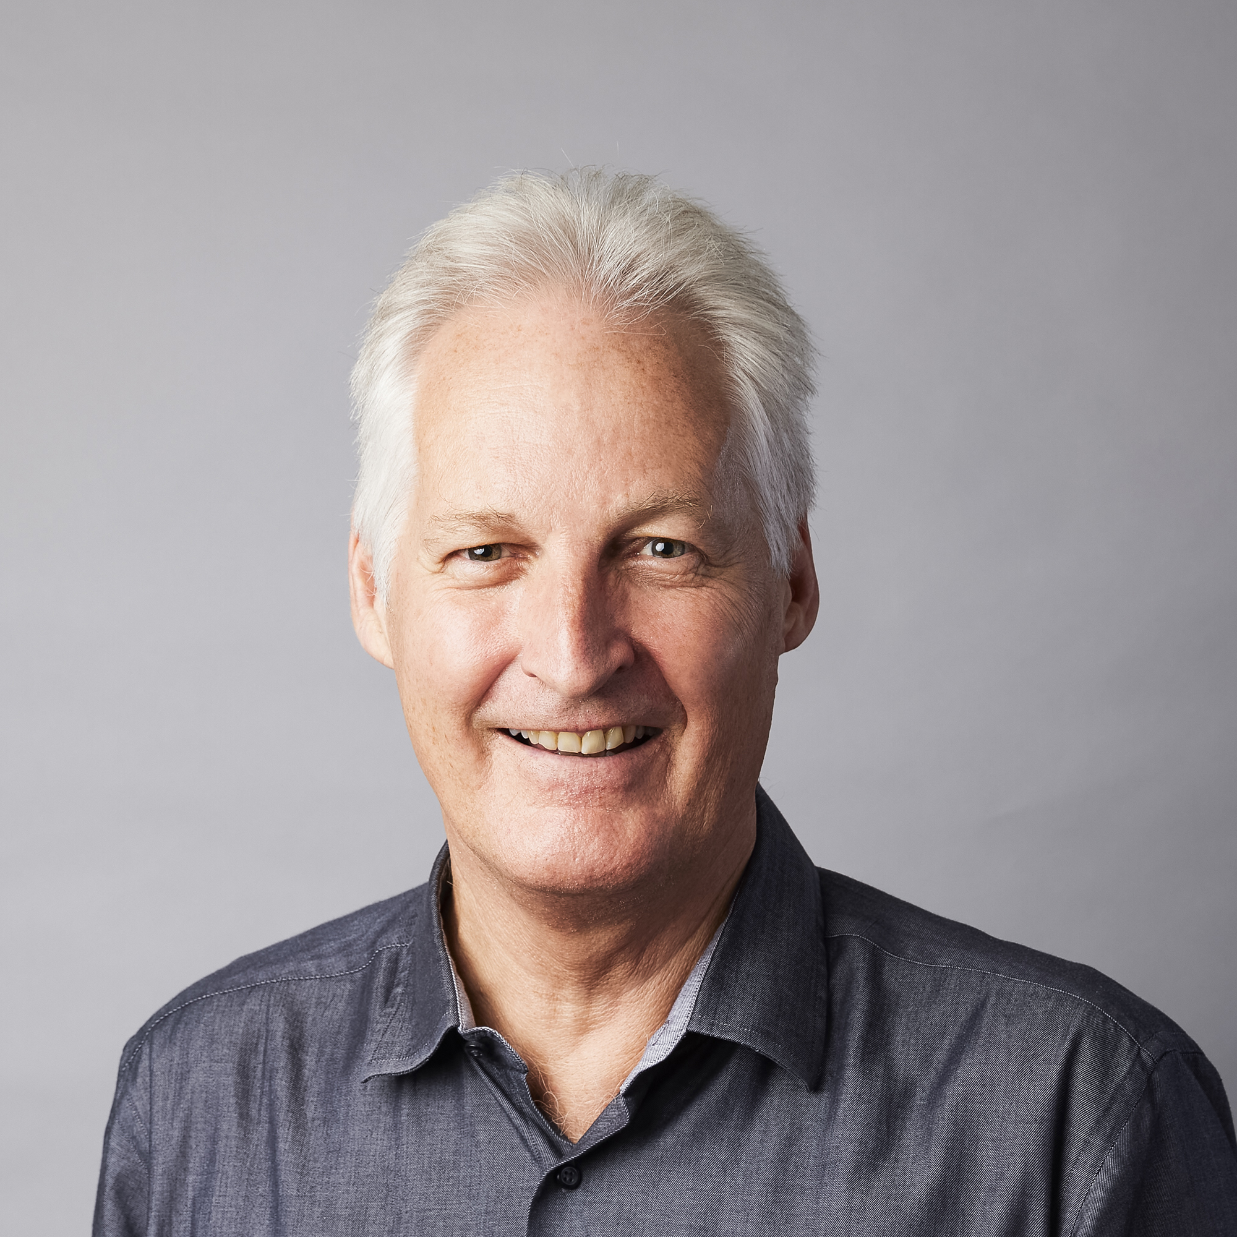

Stuart White BSc (Hons) PhD

**DIRECTOR**

Professor Stuart White is Director of the Institute for Sustainable Futures where he leads a team of researchers who create change towards sustainable futures through independent, project-based research.

Professor White was Cluster Leader of the Universities-CSIRO Intelligent Grid program. He is Chair of the Specialist Group on Efficient Urban Water Management of the International Water Association (IWA), on the board of directors for the Australian Alliance for Energy Productivity (A2EP), on the board of directors for Climate-KIC Australia and Chair of the International Water Association Specialist Group on Efficient Urban Water Management.

In 2012 he was awarded the Australian Museum Eureka Prize for Environmental Research.

**Presentation working title**:

*Where digital futures support sustainable futures*

**Abstract**:

The fourth industrial revolution is having a major impact on the world. The combination of digital technology, mobile devices, artificial intelligence and the internet of things combined with other developments means that we are facing opportunities and challenges that are every bit as potentially impactful as the previous industrial revolutions starting with the era of steam engines and mechanical production in the 18th century.

While there has been recent and appropriate scrutiny on the energy intensity of distributed ledger technology, and emerging ethical issues associated with some digital systems, e.g. artificial intelligence and facial recognition, there are significant opportunities for climate change mitigation arising from the deployment and integration of digital services. Nowhere is this more apparent than in the shift from linear and centralised utility systems and the emergence of decentralised energy resources which can have major benefits in terms of percentage of uptake of renewable energy, implementation of energy efficiency and demand side response, and the potential for a more resilient utility supply systems (including energy, water, waste, sanitation, transport and even human services such as community services including health). The ideal and sustainable future will only be able to be realised if there is alignment between the policy, regulatory, economic and technical aspects of the future deployment of digital systems and technology. This presentation will discuss these issues using examples and provide a conclusion of hope for the future.